

Project Name: ONLINE HOTEL BOOKING SYSTEM Branch PG-DAC SEPT- 2021.

Documentation On

**“ONLINE HOTEL BOOKING SYSTEM”**

PG-DAC SEPT 2021

**Guided By: Snehal Somwanshi**

Submitted By :

**Group No: 12**

* **Pranav Madlapure 210943020045**
* **Sanjay Mundhe 210943020053**
* **Darshan Todkar 210943020104**
* **Shubham Jawak 210943020114**

**Table of Contents**

**1. Introduction 4**

1.1 Document Purpose **4**

1.2 Project Background **4**

1.3 Aim & Objectives **4**

**2. Business Requirements Overview**…………………………………………………………**5**

**3.Functional Requirements** **5**

3.1 Customer Module **5**

3.2 Service Provider Module **6**

3.3 Admin Module **6**

**4.** **Non-Functional Requirement………………………………………………………………6**

**5. Use Case Diagram 7**

5.1 Admin **7**

5.2 Customer **8**

5.3 Service Provider **9**

**6. Database Design 10**

1 User **10**

2 Hotel **10**

3 City…………………………………………………………………………………… **10**

4 Booking **11**

5 Payment **11**

6 Room **11**

**7. E-R Diagram………………………………………………………………………………………12**

**8. Snapshots 13**

**9. Conclusion 25**

**List of Figures**

**Use Case Diagrams 7**

Fig 1 Admin 7

Fig 2 Customer 8

Fig 3 Owner 9

Fig 4 ER Diagram 12

1. **Introduction:**
   1. Document Purpose

This document communicates the business requirements and scope for developing Online Hotel Booking System. The scope of this document is to define the functional and non-functional requirements, business rules and other constraints requirements.

* 1. Project Background

There is no computerized system for the people to book a hotel room in a particular city. Currently, the customer physically goes to the city and look for a hotel for staying purpose, but situation may arrive that there will be no availability of room. There is no way for customers to know about price, availability of rooms.

* 1. Aim and Objective

The main objective of this project is building a website which will help customers to book their hotel rooms in different cities and for service providers to add his hotel on website. The system provides the customers the user-friendly environment to book a suitable hotel. Also provides information about all the bookings.

* 1. Customers and Stakeholders

Customers:

* Customers want to see list of hotels in a particular city and want to book hotel room.
* Service provider to add hotels.
* Admin to see details regarding bookings.

Stakeholders

* Hotel service provider.

1. **Business Requirements Overview:**

* Hotel booking System is the public web application.
* Hotel booking System will be opened to the global, but in the phase 1, the main target is in the India.
* There are mainly two types of users. One is customer and other is service provider.
* Registered customer can search for the city and a particular hotel and even he can book hotel rooms.
* Service Provider can add hotel and even he can update room status.
* Hotel booking System provides the functions which connect the customers and the hotel service provider efficiently.
* Hotel booking System could be maintained by Admin.

# Functional Requirements Overview:

Online hotel booking System consists of three modules described as below.

* Customer Module
* Service Provider Module
* Admin Module

3.1 Customer Module

* Customer can visit web application.
* Customer has to register and create his own account.
* Customer can search for hotel in a particular city.
* Customer can see hotel details.
* Hotel Booking System provides the function which allows registered customer to find out the hotel room information and book a room.
* And could find the price and availability of room in hotel.
* Customer can cancel his bookings.

3.2 Service Provider Module

* Service provider has to login.
* Service provider can add hotel.
* Service provider can see hotel booking details.
* Service provider can update about availability of rooms.

3.3 Admin Module

* Hotel Booking System should provide all function to admin how to handle the System.
* Admin should able to manage accounts of users.

1. **Non-Functional Requirement:**

* The website should use professional design, look and feel and colour scheme.
* The website should available 24/7 for customers.
* Users will have no limitations for accessing the application through Internet. The portal being an internet application, it is difficult specify exact number of visitor or users. Hence, we will target the system to support between 5 and 10 million users on launch of phase 1.
* Being a public website, the site must follow general usability guidelines for menus, navigation, colours, links and other actions provided on the screens.
* The system should be designed in such a manner that user will be able to complete tasks in minimum number of steps.

.

## 5. Use-Case Diagram

**5.1 Admin:**

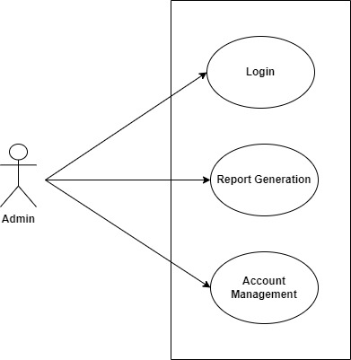

Fig. Use-Case Diagram for Admin

## 5.2 Customer:

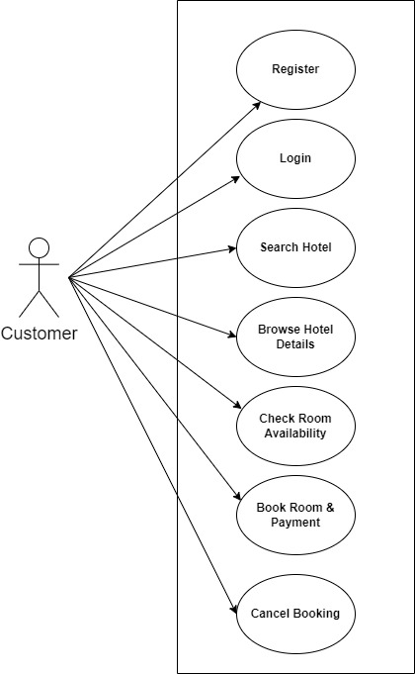

Fig. Use-Case Diagram for Customer

**5.3 Owner:**

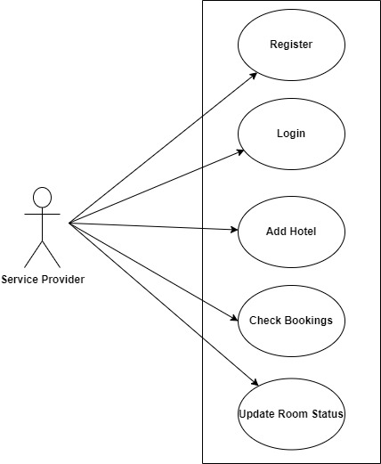

Fig. Use-Case Diagram for Owner

**6. Database Design:**

**1] Tbl_User**

|  |  |  |  |  |  |
| --- | --- | --- | --- | --- | --- |
| **Field** | **Type** | **Null** | **Key** | **Default** | **Description** |
| Uid | Integer | No | Primary key |  | User ID |
| Fname | Varchar(45) | Yes |  | Null | First Name |
| Lname | Varchar(45) | Yes |  | Null | Last Name |
| Email | Varchar(45) | Yes |  | Null | Email ID |
| Password | Varchar(15) | Yes |  | Null | Account Password |
| ContactNo | Varchar(10) | Yes |  | Null | Contact No. |
| AadharNo | Varchar(12) | Yes |  | Null | Aadhar No. |
| Address | Varchar(100) | Yes |  | Null | Permanent Address |
| UserType | Varchar(10) | Yes |  | Null | Customer/Service Provider |

**2] Tbl_Hotel**

|  |  |  |  |  |  |
| --- | --- | --- | --- | --- | --- |
| **Field** | **Type** | **Null** | **Key** | **Default** | **Description** |
| Hotelid | Integer | No | Primary key |  | Hotel id |
| HotelRegNo | Integer | Yes |  | Null | Hotel Registration No |
| Hname | Varchar(45) | Yes |  | Null | Hotel Name |
| Address | Varchar(45) | Yes |  | Null | Hotel Address |
| Email | Varchar(45) | Yes |  | Null | Email Address |
| ContactNo | Varchar(45) | Yes |  | Null | Contact Number |
| Image1 | Varchar(45) | Yes |  | Null | Hotel Image File name 1 |
| Image2 | Varchar(45) | Yes |  | Null | Hotel Image File name 2 |
| Ac_Room | Integer | Yes |  | Null | Total ac rooms |
| Non_Ac_Room | Integer | Yes |  | Null | Total non ac rooms |
| Cityid | Integer | No | Foreign key |  | Reference to Cityid (Tbl_City) |
| Uid | Integer | No | Foreign key |  | Reference to Uid(Tbl_User) |

**3] Tbl_City**

|  |  |  |  |  |  |
| --- | --- | --- | --- | --- | --- |
| **Field** | **Type** | **Null** | **Key** | **Default** | **Description** |
| Cityid | Integer | No | Primary key |  | City ID |
| CityName | Varchar(20) | Yes |  | Null | City name |

**4] Tbl_Room**

|  |  |  |  |  |  |
| --- | --- | --- | --- | --- | --- |
| **Field** | **Type** | **Null** | **Key** | **Default** | **Description** |
| Rid | Integer | No | Primary key |  | Room ID |
| RoomType | Varchar(20) | Yes |  | Null | Room name |
| RateperDay | Double | Yes |  | Null | Room rate per day |
| Image1 | Varchar(20) | Yes |  | Null | Room image 1 |
| Image2 | Varchar(20) | Yes |  | Null | Room image 2 |
| Hotelid | Integer | No | Foreign key |  | Reference to Hotelid (Tbl_Hotel) |

**5] Tbl_Booking**

|  |  |  |  |  |  |
| --- | --- | --- | --- | --- | --- |
| **Field** | **Type** | **Null** | **Key** | **Default** | **Description** |
| Bookingid | Integer | No | Primary key |  | Booking ID |
| BookingDate | Date | Yes |  | Null | Booking Date |
| Rid | Integer | No | Foreign key |  | Hotel ID |
| Checkin | Date | Yes |  | Null | Check in Date |
| Checkout | Date | Yes |  |  | Check out Date |
| Uid | Int | No | Foreign Key |  | Uid Reference to Uid(Tbl_User) |
| TotalCost | Double | Yes |  | Null | Total Cost of Booking |
| Status | Varchar(20) | Yes |  | Null | Booking Status |

**6] Tbl_Payment**

|  |  |  |  |  |  |
| --- | --- | --- | --- | --- | --- |
| **Field** | **Type** | **Null** | **Key** | **Default** | **Description** |
| Paymentid | Integer | No | Primary key |  | Payment ID |
| PaymentMode | Varchar(20) | Yes |  | Null | Payment Mode |
| Bookingid | Integer | No | Foreign Key |  | Bookingid Reference to Bookingid(Tbl_Booking) |
| Transactionid | Integer | Yes |  | Null | Transcation id |
| Uid | Integer | No | Foreign key |  | Reference to Uid(Tbl_User) |

## 7. ER-Diagram:

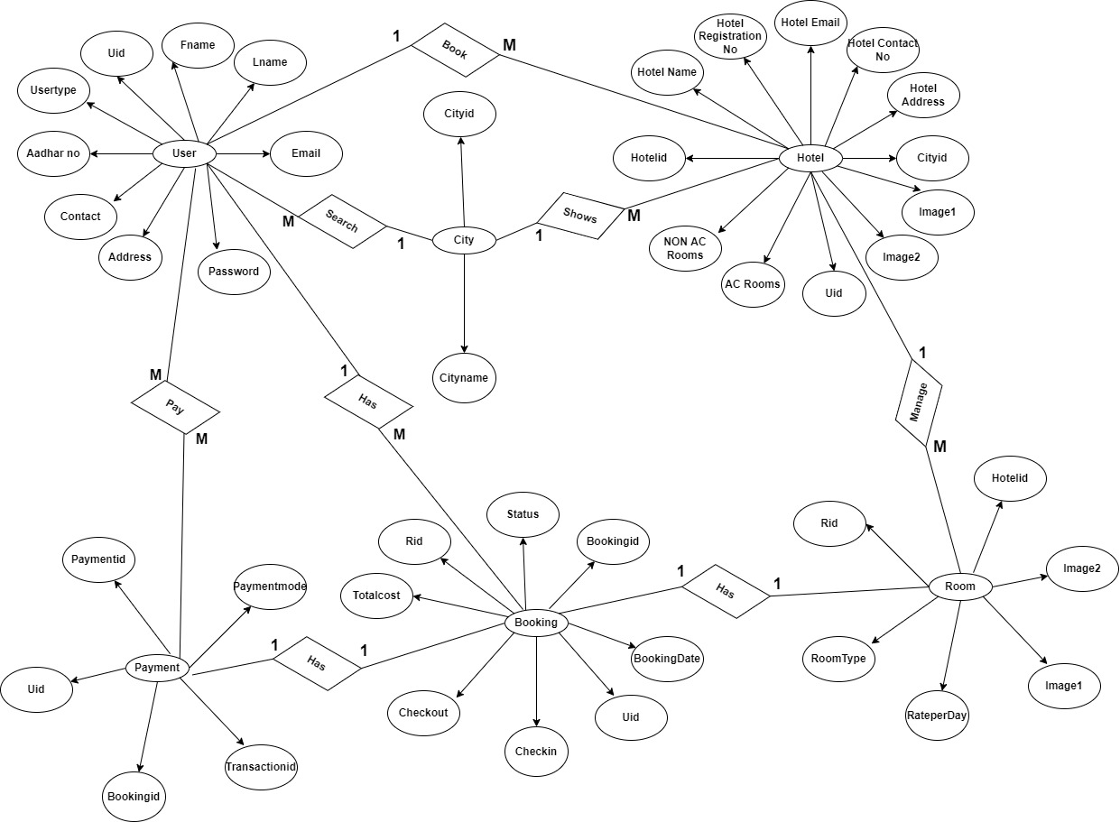

**E-R diagram shows database of Online Hotel Booking System**

**Snapshots:**

**8 Customer Module**

**8.1 Home Page:**

Following snapshot shows the Home page for Online Hotel Booking System

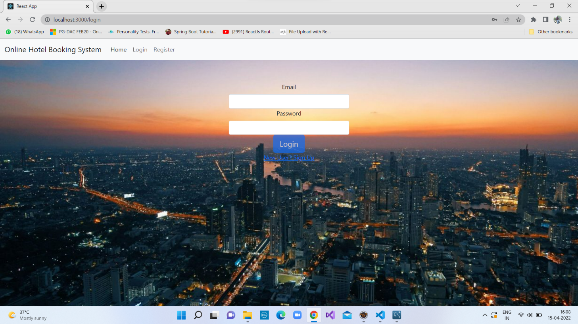

This page contains following controls

* Home
* Login
* Register

**8.2 Customer Home Page**

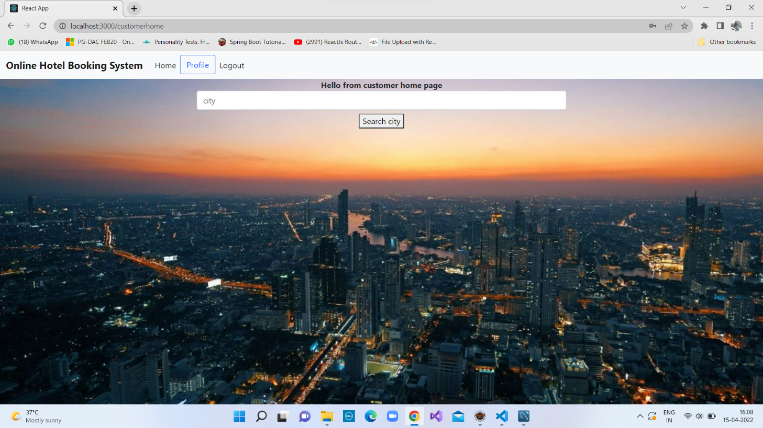

**8.3 List of Hotel**

Following snapshot shows the List of hotel in particular city page for Online Hotel Booking System

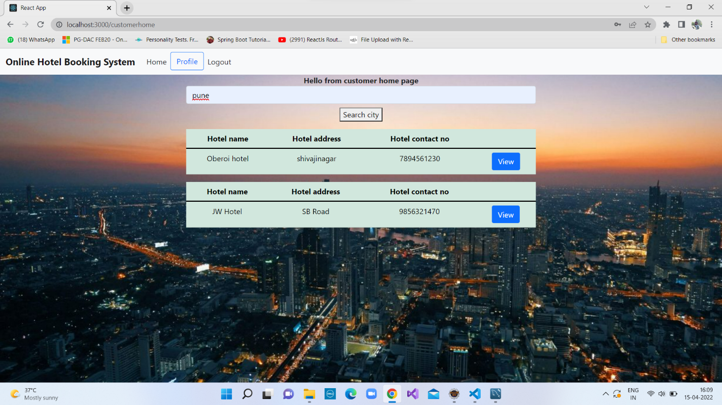

**8.4Particular Hotel Details**

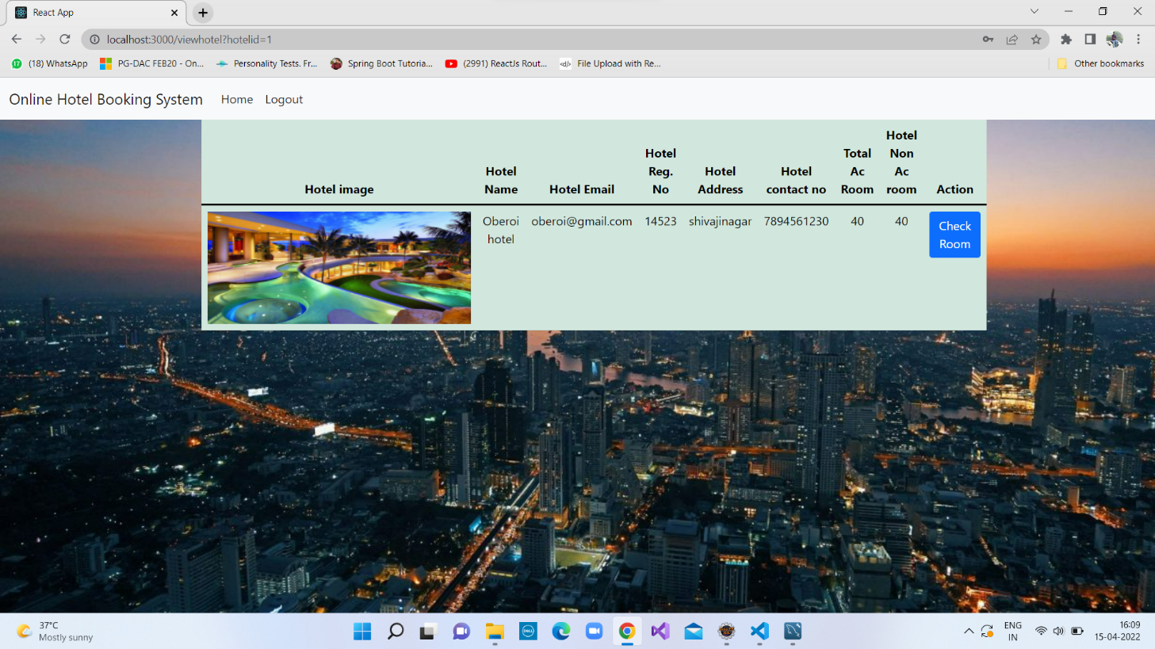

**8.5 Check Room in Particular Hotel**

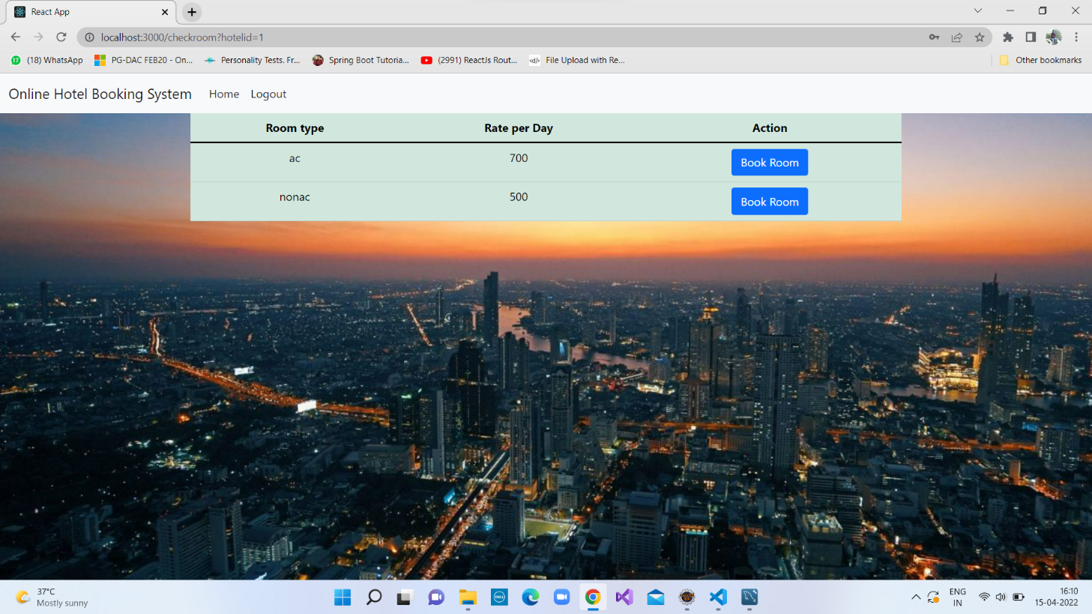

**8.6 Book Room**

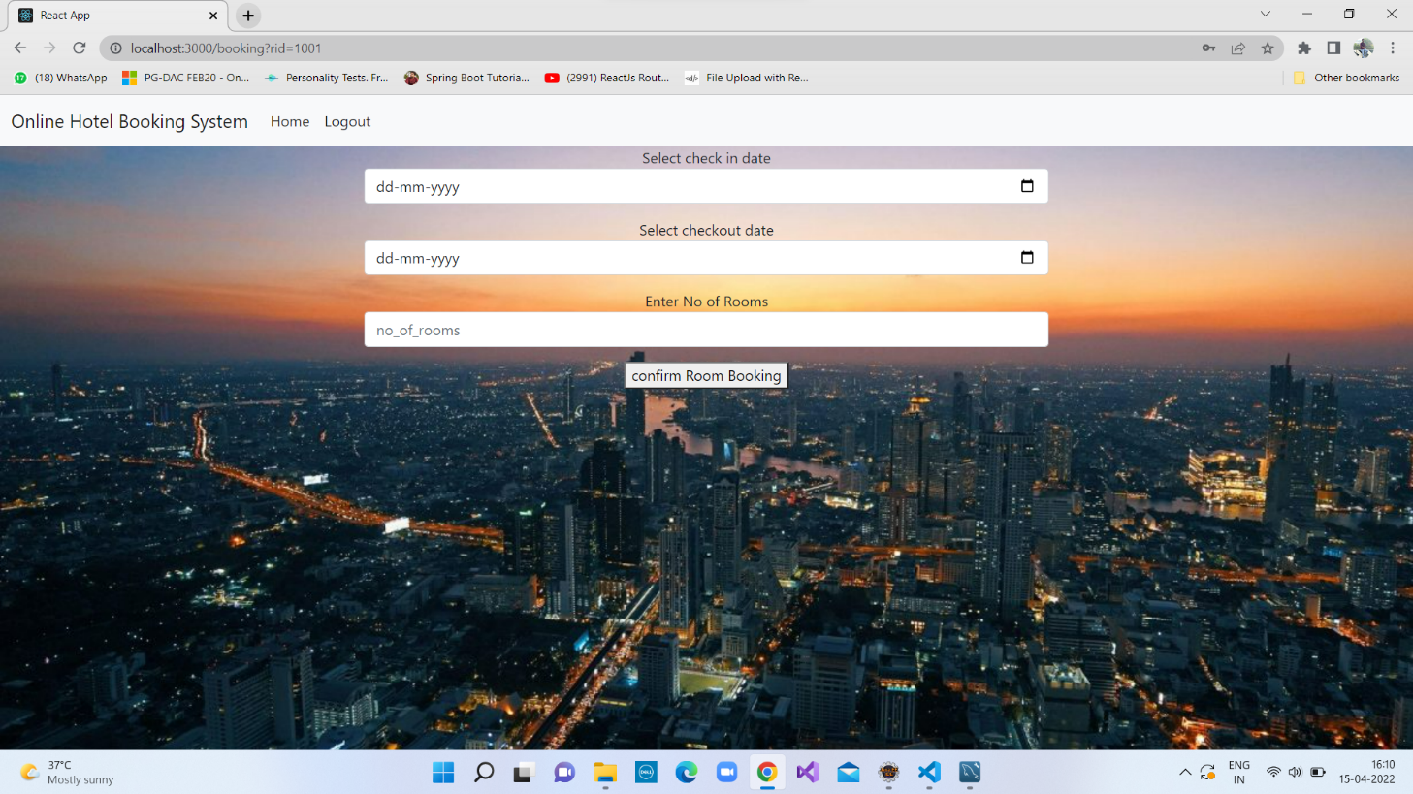

**8.7 Payment Page**

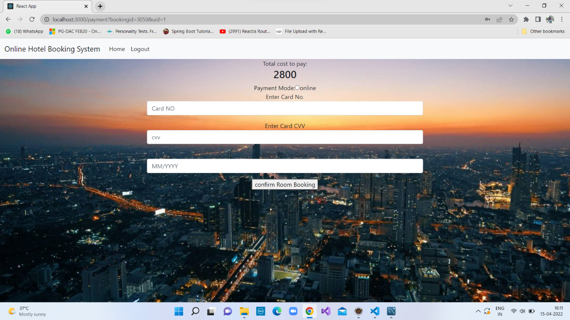

**8.8 Payment Details Page**

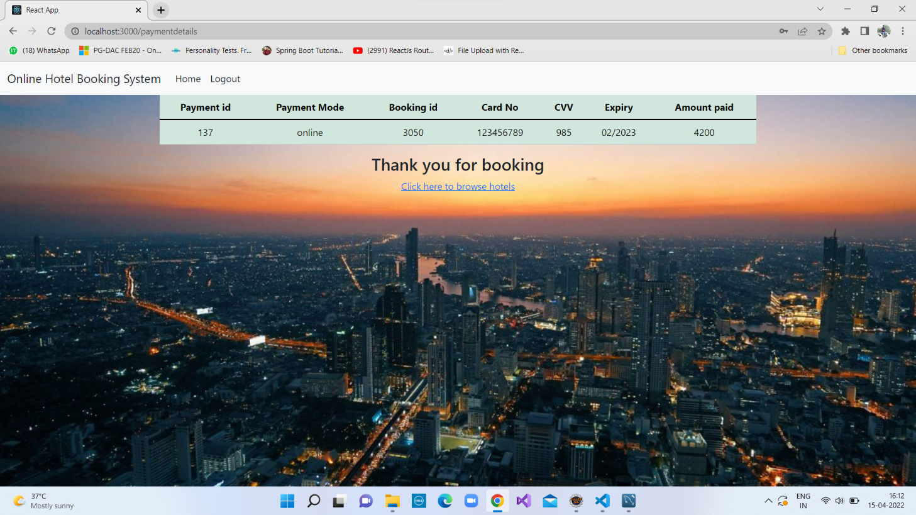

**9 Service Provider Module**

**9.1 Service Provider homepage**

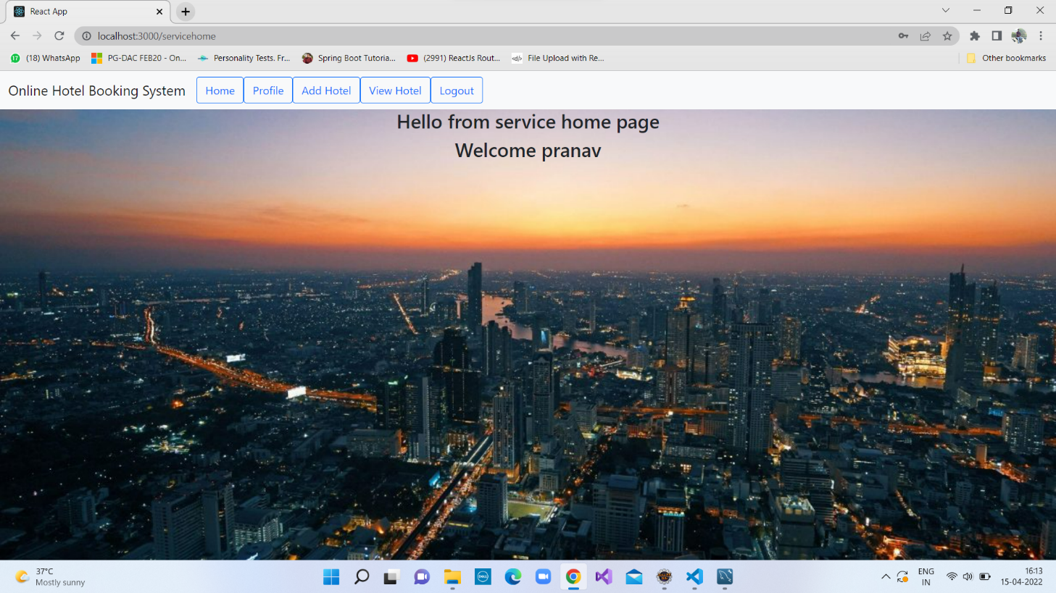

**9.1 Service Provider Profile Update Page**

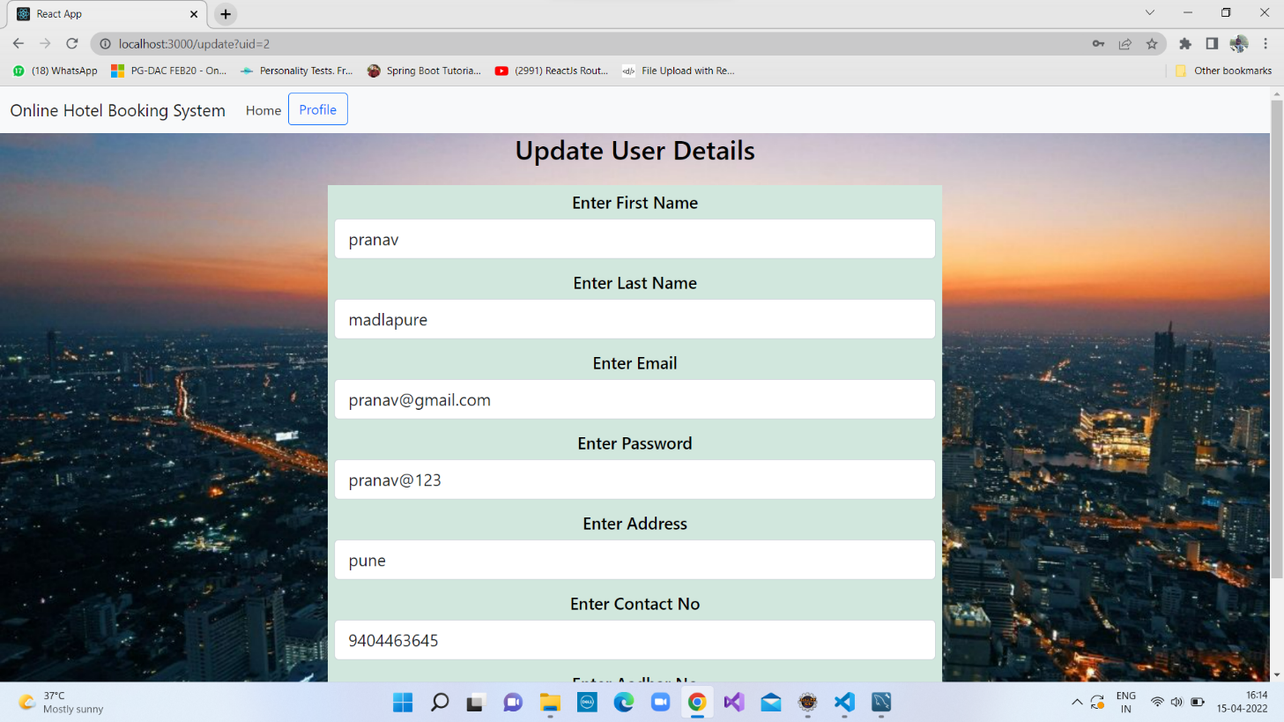

**9.2 Add Hotel**

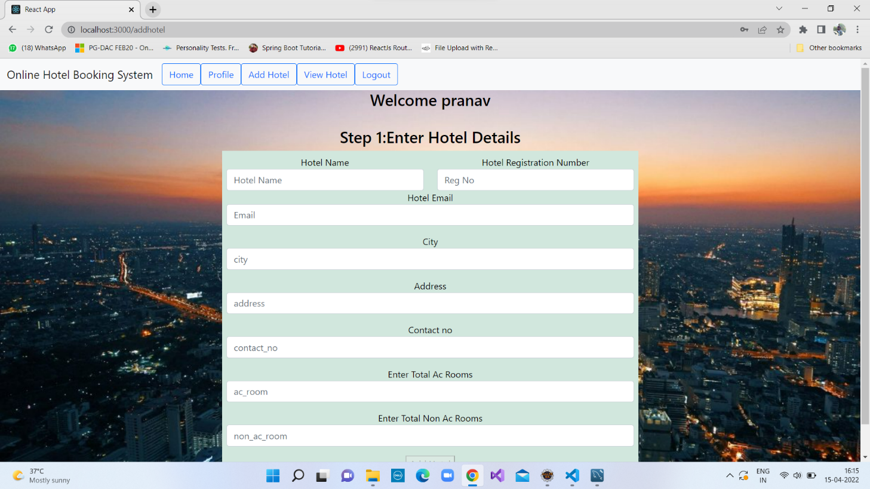

**9.3 List of Hotels**

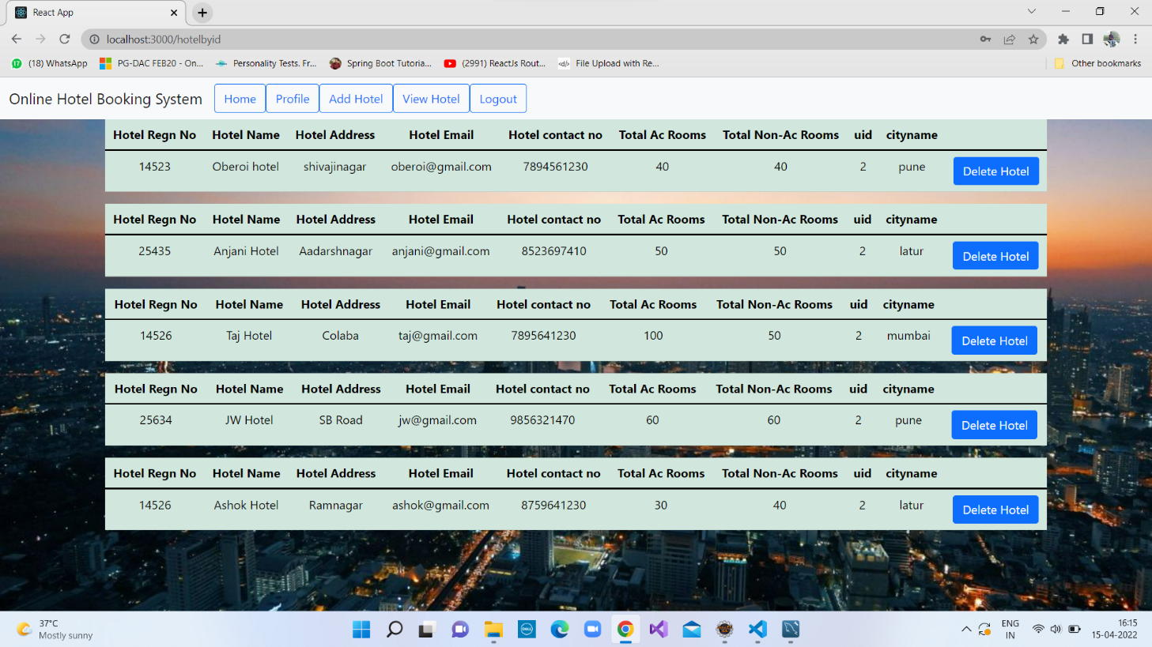

**10 Admin Module**

**10.1 Admin Home Page**

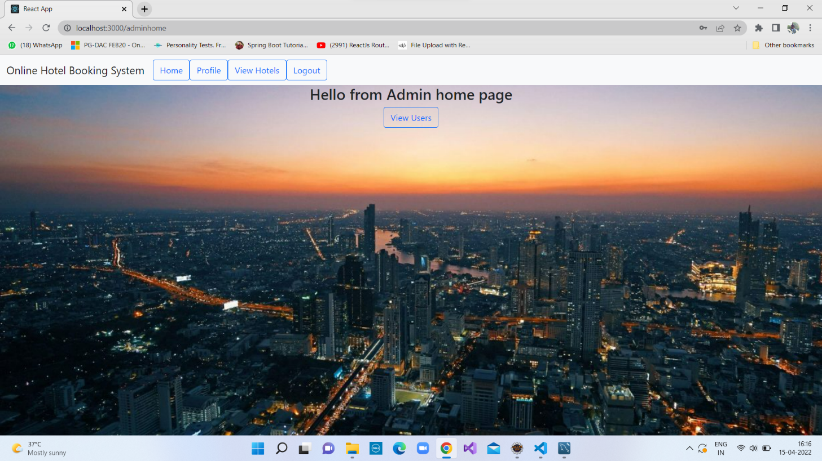

**10.2 View List of Hotels**

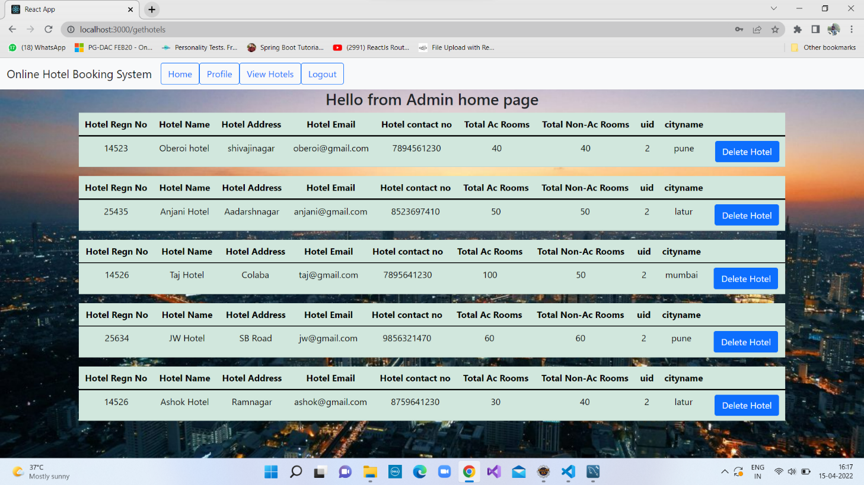

**10.3 View List of users**

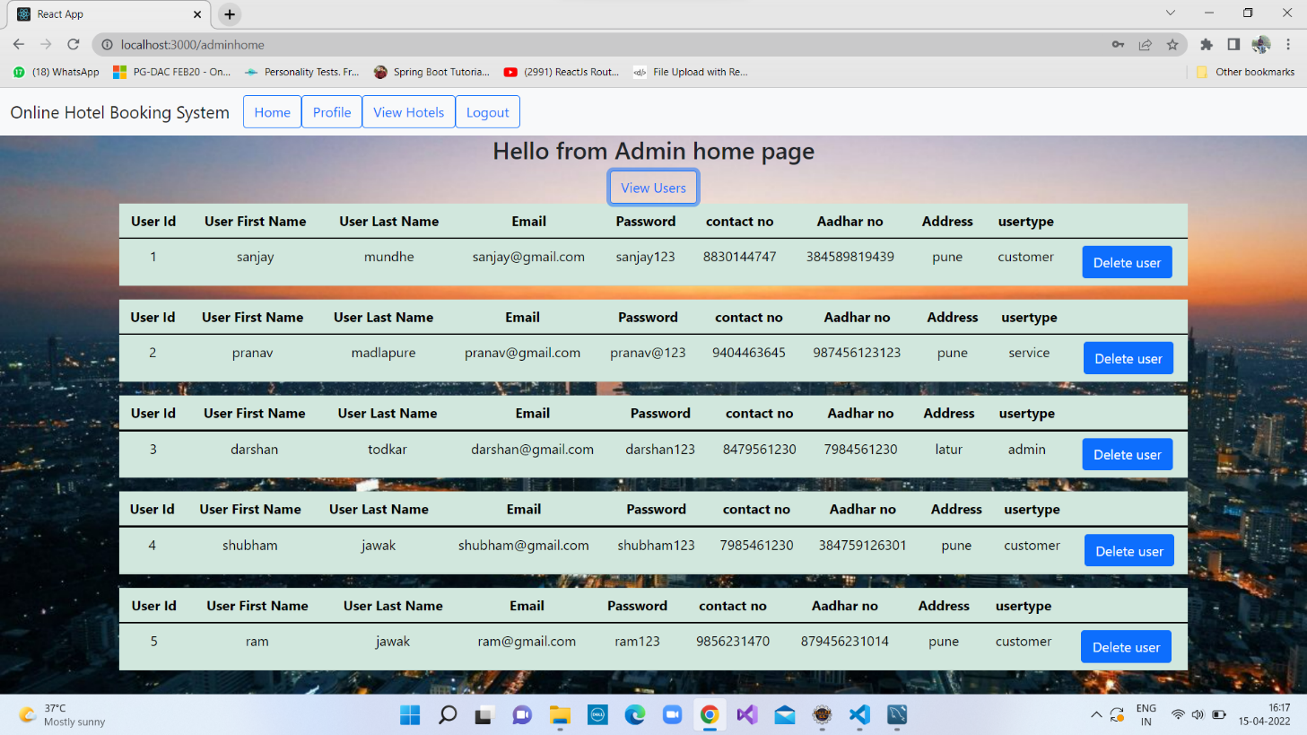

**10.4 Logout Page**

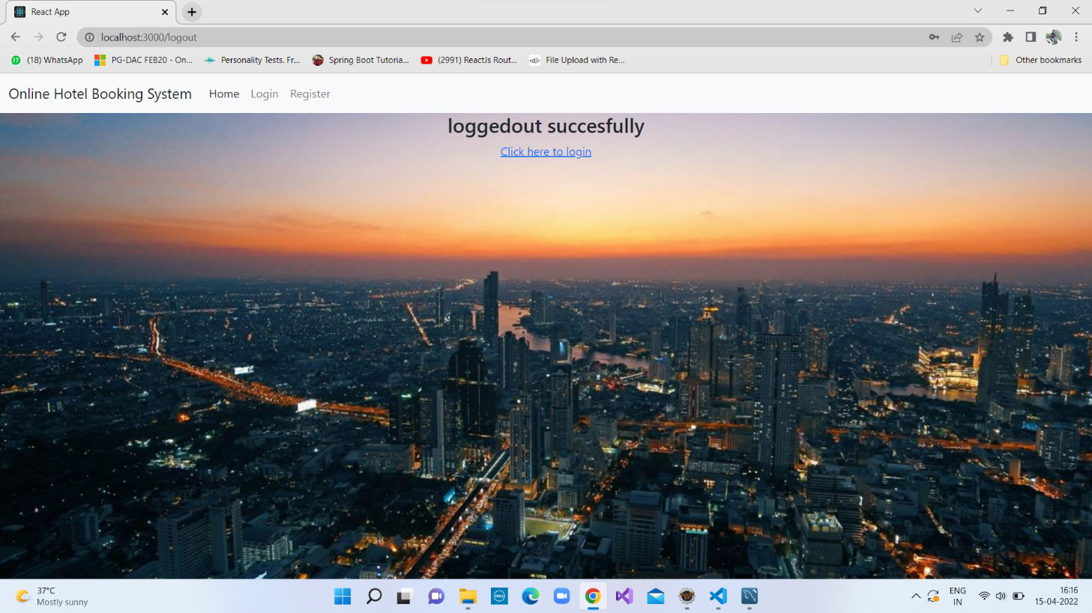

**9. CONCLUSION AND FUTURE SCOPE**

Online Car & Bike Rental System provides better Vehicle booking on rent platform to customer and Owner can get the business for their vehicle efficiently.

Our System provides a very user-friendly platform where Customer can easily search the vehicle, Book the vehicle, see the booking and Make payment for vehicle booking on rent also Owner will Register the vehicle, See the vehicle booking and owner can also delete the register vehicle.

Our system is aimed efficient management of various tasks like booking the vehicle for Customer on daily basis, managing payment for booking, adding the vehicle. Monitor daily Booking along with managing all the Account and information on a single platform.